W1 = 1

W2 = 1

B = 0

x $\left\{\begin{aligned}x>0 , y=1 \\ x≤0 , y=0\end{aligned}\right.$

X1 = 0, X2 = 0

0\*1+0\*1+0 = 0

X1 = 1, X2 = 0

1\*1 + 0\*1 + 0 = 1

X1 = 0, X2 = 1

0\*1 + 1\*1 + 0 = 1

X1 = 1, X2 = 1

1\*1 + 1\*1 + 0 = 2

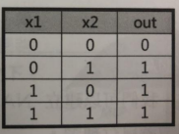

x1\*w1+x2\*w2+b

W2=1

W1=1